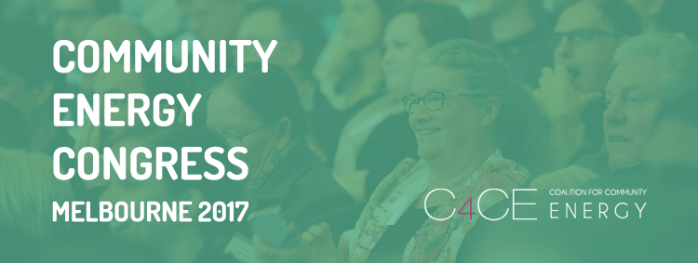

Why you need to attend Congress 2017

The Community Energy Congress is just around the corner so now is the perfect time to start fundraising so your community group can attend Australia’s seminal community energy event.

On February 27-28, over 500 clean energy advocates will descend on Melbourne for a huge educational and inspirational experience. Congress 2014 was a defining time in the community energy space and nearly 350 people helped put the sector on the map. Congress 2017 is going to be bigger, more informative, more diverse and a whole lot more fun.

The Congress will be two-day event with a number of side activities held before and after, including training sessions, master classes and field trips. The focus of the Congress 2017 will be on supporting community energy actors to implement existing community energy models and develop new innovative approaches. This will include but not be limited to:

- Community engagement,
- Developing partnership models with renewable energy industry,
- Whole of community blueprint plans,
- Establishing behind-the-meter community solar models,
- Host-site identification and negotiation and community retailing, and
- Identifying opportunities for Local Energy Trading (Virtual Net Metering).

What are the aims of the event?

There is something for everyone, from those who have been working the community energy sector for years, to those who are just starting out. The goal is to leave everyone inspired to create change in their communities. Attendees will also:

- Develop pathways for collaboration,
- Identify key opportunities and barriers facing the sector,
- Learn from successful examples of community energy,
- Share information and strategies about overcoming barriers, and
- Consolidate and coordinate efforts nation-wide.

How can you raise funds?

If a whole group of you wish to attend it will be ideal to put a fundraising strategy in place. That way you can work together and individually to meet your goals.

- Work out cost per person and see if anyone can afford to subsidise their trip,
- Figure out how much personal versus group effort is required,
- See if you can save money on accommodation by booking as a group,
- Work out if there is scope for sponsorship opportunities,
- Create a list of people and organisations you can approach for donations:
- Local politicians
- Businesses
- Local government (many have small grant programs)
- Environment groups
- Community service clubs
- Community banks
- Universities
- Use the template letter below as a starting point
- Create a list of fundraising activities that are quick and easy to organise
- Chocolate drives
- Sausage sizzles
- Trivia nights
- Movie nights
- Stalls
- Tin rattling

What else you need to know

The Community Energy Congress is an initiative of the Coalition for Community Energy (C4CE). C4CE is governed by a Steering Group which includes representatives from Australia’s leading community energy organisations – Embark, Moreland Energy Foundation and the Alternative Technology Association. The Congress organising will be led by Community Power Agency (CPA) who acts as the C4CE Secretariat. The C4CE team has a strong track record of delivering inspiring events that benefit the growth of the community energy sector in Australia.

[Enter your name]
[Your Address]

[Enter Name of Person/NGO]
[Enter Street No, Street Name]
[Enter Suburb, State]

[Enter Month, date, 2016]

Dear [insert],

I am a representative of [Enter community energy group’s name] and I live in [your local community]. Next February, I hope to attend and represent our organisation at the Community Energy Congress, organised by the Coalition for Community Energy. I am hoping to secure financial support to attend the event.

What is the Community Energy Congress
The C4CE Community Energy Congress is an event driven by the desire across Australia for people to work together to develop and deliver sustainable, locally owned energy projects. Congress 2017 will bring together up to 800 people to strengthen the budding community energy sector. Together we will share information, develop skills, foster new networks, celebrate success and plan for action. Grassroots energy enterprises, which number more than 80 nation-wide, harness the power of communities to increase local energy security, bolster regional development partnerships, enhance community cohesion and reduce carbon emissions

Why support community energy
[Insert a couple of sentences about why the person/organisation you are asking money from should care about/be interested in community energy]

Aims of the congress
The Congress is a seminal event in Australia aiming to bring together stakeholders to:
- Be inspired to create change in their communities;
- Develop skills and build capacity to deliver community energy projects;
- Develop pathways for communities, companies, and governments to collaborate;
- Identify key opportunities and barriers facing the sector;
- Learn from successful examples of community energy in Australia and worldwide;
- Facilitate sharing of information and strategies, and
- Consolidate and coordinate efforts across the nation in this emerging sector.

Your support
I am seeking your financial support to assist in meeting:

- The conference registration fee of [Enter Amount $.00] which covers the cost attending workshops and conference events, conference materials, accommodation and meals, and
- Transport costs for a return trip from [location] to Melbourne. I estimate this will be [Enter $.00].

Should you wish to make a contribution, a payment can be made directly to me, or care of [insert registered group details here]. Invoices and receipts can be provided. Please do not hesitate to contact me with any questions you may have on [enter phone number] or alternatively via email [enter email address].

Thank you for reviewing this letter.

Yours sincerely,

[Your signature]

[Enter your name]
[Enter Your Environment Collective Name]

