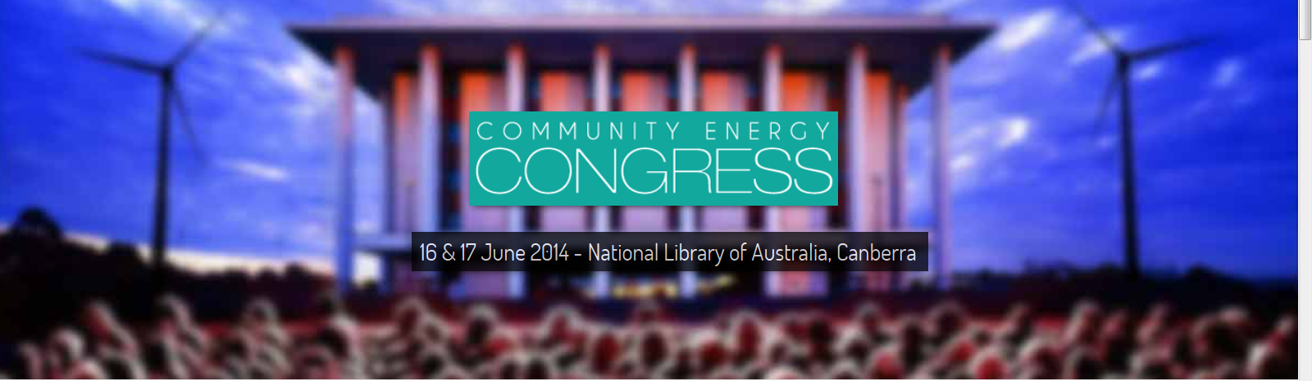

DATE

NAME
POSITION
ORGANISATION
ADDRESS 1
ADDRESS 2

Dear

Request for Support

Inaugural National Community Energy Congress

We are writing to seek your financial support for a delegation of local volunteers working on [LOCAL PROJECT NAME] to attend the inaugural National Community Energy Congress on 16 & 17 June at the National Library in Canberra.

About our Project
SHORT DESCRIPTION OF YOUR LOCAL PROJECT

About the Congress
The 2014 Community Energy Congress aims to create a new and sustainable approach to energy in Australia ~ to de-carbonise, de-centralise and democratise our energy system!

The Congress is being organised by the Institute for Sustainable Futures (part of the University of Technology Sydney) and the Coalition for Community Energy (C4CE) ~ which is a collaborative network of nearly a dozen Australian community energy charities and non-profit organisations.

[LOCAL PROJECT NAME] is one of more than forty community energy projects across Australia. This movement highlights how communities are coming together to pursue genuine sustainability opportunities ~ and few of which are as compelling as community energy projects.

Communities are leading the way in creating sustainable energy enterprises that increase local energy security, create regional community development opportunities, and directly act to reduce carbon emissions.

The Community Energy Congress will bring together for the first time, all the key players in the emerging Australian community energy sector.

For more details see: www.c4ce.net.au/congress.

Benefits for [LOCAL PROJECT NAME]
We believe that the Community Energy Congress will provide practical benefits to [LOCAL PROJECT NAME], and the wider community including:
  - Further develop our knowledge and skills for our community energy project
  - Build relationships and networks with those who work in community energy in Australia, including people from mainstream energy networks, retailers and renewable energy businesses as well as government and community energy project leaders
  - Find more ways of how community energy can be used to promote sustainable regional development and renewable energy sector development in Australia
  - Learn more about renewable energy technologies; community energy business models; energy regulatory and policy processes, reforms and opportunities
  - Provide input into the Community Energy Strategy for Australia including helping to identify and refine strategies to grow the community energy sector across Australia

Support Request
As a volunteer-based and not-for-profit local group, we are seeking financial support to assist a delegation of [INSERT TARGET NUMBER] local volunteers. Specifically we need to raise $X,XXX funds to cover:

  - Conference registration fees ~ $170pp (early bird) | $260pp (standard)
  - Travel for a return trip from [LOCATION] to Canberra
  - Meals and accommodation

Please feel free to contact me should you wish to discuss this further or require any additional information.

We look forward to your consideration of our request.

Sincerely yours,

YOUR SIGNATURE

YOUR NAME
YOUR POSITION
YOUR LOCAL PROJECT|ORGANISATION
YOUR CONTACT DETAILS
YOUR ADDRESS

