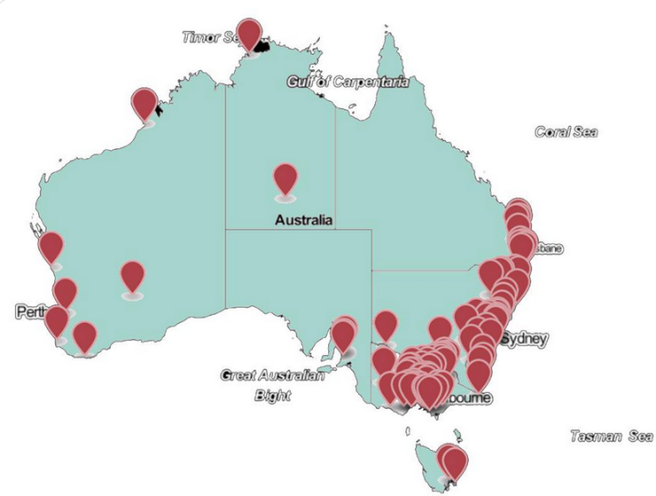
About Community Energy
Image by Community Power Agency cpagency.org.au
Community energy is clean energy with a difference because it allows the community to get involved. There’s no single model because every group in Australia has looked at what suits them and their community best. And maybe that’s the way our energy system should evolve?
The main outcome of community energy is the unlocking of local benefits that existing energy markets have failed to deliver so far.

For example:
- Delivering the profit of renewable energy projects to a broader section of the community rather than a few corporate investors
- Unlocking projects (renewable energy and energy efficiency) that wouldn’t otherwise occur by developing projects, by reducing costs and by offering finance.
- Helping communities rethink what the energy system of the future might look like and advocating for solutions that are more equitable, efficient and resilient.

Community Energy and State government support
NSW and Victoria have led the way in supporting the community energy sector. NSW has given grants to regional communities for a number of years to support clean energy projects and action planning. Victoria’s New Energy Jobs Fund has created an injection of funds into regional initiatives in the wake of the closure of Hazelwood Power Station. A State Government strategy needs to match the maturity of the sector in each state.

South Australia is at the start of its journey

Queensland, WA and Tasmania have some activity on the ground

NSW and Victoria are starting to mature

In February 2017, the SA government supported 10 people to attend the Community Energy Congress with a $10,000 grant.
Community Energy in South Australia
CORENA, Citizens Own Renewable Energy Network Australia, dedicated to reducing climate emissions with solar and energy efficiency, is one of the sector’s most successful models. Operating nationally, with $250,000 of donated funds under management, the CORENA revolving fund model has just funded its 26th project for $42,000.
Solar Harvest is a Barossa-based community energy initiative, looking to form a cooperative. They have just completed the Coop incubator program and will shortly launch their first fundraising round.
Community Energy and Federal government support
The federal landscape offers a few funding opportunities:
- The Energy Efficient Communities Program, opens on 1 September 2019 and will provide $50 million in grants to help businesses and community organisations undertake energy efficiency assessments and upgrades.
- The Supporting Reliable Energy Infrastructure program includes $50.4 million to support feasibility studies into the development of microgrids in regional and remote communities.
These are not expected to be delivered through community energy groups but will help partnerships with relevant projects.
ARENA and the Climate Solutions Fund are both possible sources of funding but tend to be tailored toward much larger projects and more established proponents.
Community energy and Local government support
Local Government in South Australia has seen the need to support its communities. The following ideas are under development:
- Resilient Hills and Coasts (6 Councils) commissioned a proposal for a Community Energy Program. They have now developed legal models and are restarting community engagement.
- Adelaide CC, Pt Pirie and Eyre Peninsula have all developed solar programs.
- Campbelltown CC championed the development of a solar calculator for community projects but could not make the business case on a number of their buildings for a community-led investment.
- The Western metro councils are exploring ideas to weather proof housing for extreme heat, which would have the added benefit of reducing bills via an insulation and possible solar investment.
What would we like to see from State Government?
We would like to see a deliberate conversation about community energy that allows MPs to understand the benefits of a dedicated community energy strategy and the opportunities within their own communities.
This would allow State Government to develop a funded strategy with bipartisan support to grow the community energy sector in South Australia.

