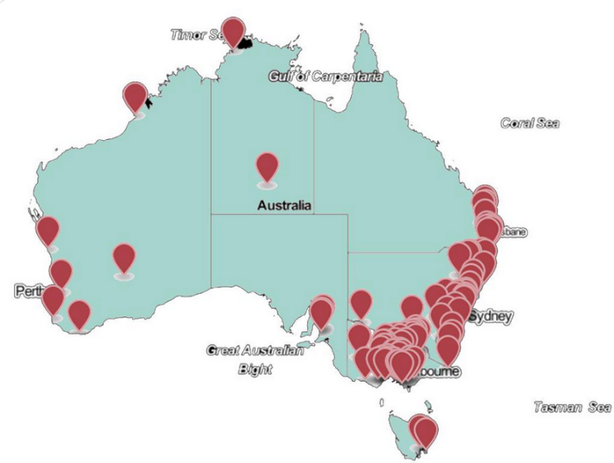
Name:
Image by Community Power Agency cpagency.org.au
Location:
Date
Submission to ‘Unlocking the community energy opportunity in Australia’
Thank you for the opportunity to make a submission to the co-design process for unlocking the community energy opportunity and developing a renewable energy plan for regional Australia.

My organisation is ….

Our model of operating is…
We support the C4CE proposals:
- Determine a Target for community energy (Community Energy Target)
- Establish a financial mechanism for mid-scale community energy projects
- Scale up the Community Power Hub Program to be national
- Deploy strategic community energy grant funding
- Support the 100 renewable and zero-carbon community movements
- Support a collaborative Community Energy Capacity Building Network and utilise existing networks in each state to best deliver this
- Prioritise a socially inclusive energy transition with specific programs for groups such as renters and those on low incomes
- Incentivise use of the low voltage and 22kV grid for community energy projects, generation and storage, in order to avoid augmentation and upgrades of the NEM and enable a faster transition

We offer the following answers to your questions:
Our experience
1) What role do you see renewable energy playing in the future of your community?
2) What do people in your community think about renewable energy?
3) What message about renewable energy is most important for regional Australia?
Benefits
4) In your view, what are the most important benefits of community energy?
5) Can you outline how community energy has benefitted your community?
6) Are there other benefits of community energy not outlined in this paper?
Barriers
7) In your view, what are the most important barriers to community energy?
8) Can you outline any barriers to community energy you have experienced?
9) Are there other important barriers to community energy not outlined in this paper?
Acceleration
10) In your view, what are the most effective measures to support community energy?
11) Have you received any support from Government before? How has it helped you?
12) Are there other policies not outlined in this paper to support community energy?

